**Power BI Project Documentation for SuperStore Sales Dataset**

**1. Project Overview**

* **Objective**: Analyze and visualize the SuperStore Sales dataset to extract insights on sales performance, regional trends, product segments, and customer segments.
* **Dataset Name**: SuperStore_Sales_Dataset
* **Primary Audience**: Business stakeholders and analysts who need data-driven insights for decision-making.

**2. Data Preparation**

* **Dataset Structure**: The dataset includes columns such as category, city, country, customerID, customer name, order date, order ID, payment mode, processing time, product ID, product name, profit, profit margin, quantity, region, sales, sales per item, segment, ship date, ship mode, and total value.
* **Data Cleaning Steps**: Performed necessary transformations, such as:
  + Formatting date columns (Order Date, Ship Date) for consistency.
  + Removing duplicate entries and handling missing values, particularly in Profit Margin and Processing Time.
* **Calculated Columns**: Created additional metrics, such as:
  1. **Total Value** as Sales + Profit
  2. **Sales per Item** as sales / quantity
  3. **Profit Margin** as Profit / Sales *100
  4. **Processing Time** as Ship Date – Order Date
* **Key Measures**: Defined critical measures using DAX to capture business metrics like Total Sales, Average Profit Margin, and Processing Time Analysis.

**3. Data Modeling•**

* Single-Table Structure: The model relies on a single comprehensive table containing all relevant columns (e.g., category, city, country, customerID, order date, product ID, profit, quantity, region, sales, etc.).
* Simplified Data Model: With all data in one table, no relationships or dimension tables are needed. This setup minimizes data redundancy and simplifies analysis.
* Advantages: The single-table structure allows direct access to all fields without the need for complex joins, which is particularly beneficial when working with relatively straightforward datasets like this one.

**4. Report Design**

* Page Layout: Created a single-page report that showcases the key performance metrics and insights from the SuperStore Sales dataset.
* Visualizations:
* Sum of Sales by Region (Bar Chart): Displays total sales across different regions (West, East, Central, and South) to highlight regional performance.
* Sum of Sales by Month (Line Chart): Shows monthly sales trends, enabling the identification of peak and off-peak sales periods.
* Sum of Sales by Category (Pie Chart): Breaks down total sales by product category (Office Supplies, Technology, and Furniture), providing insight into product line performance.
* Filters and Interactivity:
* Filters: Applied slicers for Category and Region to allow users to drill down and explore specific areas of interest within the dataset.
* Interactive Elements: Enabled cross-filtering between charts. For example, selecting a category in the pie chart updates the bar and line charts to reflect sales trends for that category specifically.
* Page Navigation: Given the single-table model and simplified structure, a single-page report provides a clear, consolidated view of the key metrics without the need for navigation across multiple pages.

**5. Visualizations Used**

1. Sum of Sales by Region (Bar Chart)

* Description: This bar chart presents the total sales amount segmented by different regions—West, East, Central, and South. The visualization helps to identify the regions generating the highest and lowest sales.
* Insight: From the chart, it’s visible that the West region leads in total sales, while the South region has the lowest sales figures. This insight can guide targeted marketing and sales strategies.

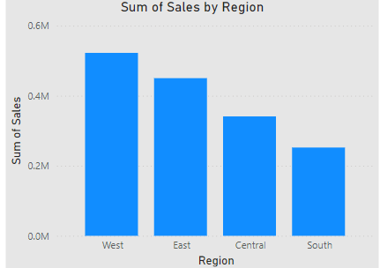

1. Sum of Sales by Month (Line Chart)

* Description: A line chart displaying monthly sales trends throughout the year. This visualization enables the identification of peak and off-peak sales months.
* Insight: The chart reveals seasonal trends, with notable sales increases in certain months, suggesting periods of high demand that could align with holidays or seasonal buying behaviors.

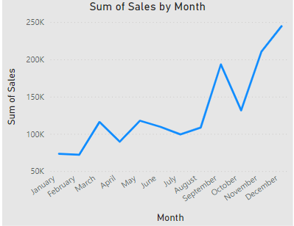

1. Sum of Sales by Category (Pie Chart)

* Description: A pie chart dividing total sales into three product categories: Office Supplies, Technology, and Furniture. Each segment represents the proportion of sales contributed by each category.
* Insight: Technology products contribute the highest percentage to overall sales, followed by Furniture and Office Supplies. This insight aids inventory and promotional planning by highlighting the most profitable product lines.

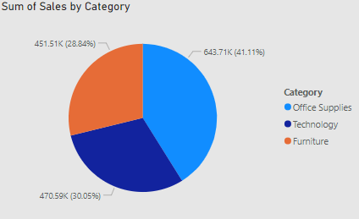

**6. Key Insights**

* **Sales Trends**: Notable seasonal peaks in specific months, indicating a cyclical sales pattern.
* **Product Categories**: Certain categories consistently outperform others, with some regions showing higher demand for specific products.
* **Regional Performance**: Identified high-profit-margin regions, aiding in targeted marketing and inventory planning.
* **Customer Behavior**: Segmented customers based on purchase frequency and total spending, uncovering top-performing customer segments.

**7. DAX Queries and Calculations**

* **Key DAX Formulas**: Utilized custom DAX measures like:

1. **Avg Sales per Customer**

Avg Sales per Customer =

AVERAGEX(

VALUES('SuperStore_Sales_Dataset'[customer ID]),

CALCULATE(SUM('SuperStore_Sales_Dataset'[Sales]))

)

**Description:** This measure calculates the average sales for each customer. It uses the VALUES function to get a unique list of customer IDs and then calculates the total sales for each customer using CALCULATE and SUM, finally averaging these totals with AVERAGEX.

1. **Customer Lifetime Value**

Customer Lifetime Value =

CALCULATE(

SUM('SuperStore_Sales_Dataset'[sales]),

ALLEXCEPT('SuperStore_Sales_Dataset', 'SuperStore_Sales_Dataset'[customer ID])

)

**Description:** This measure computes the total sales attributed to each customer, effectively representing their lifetime value. ALLEXCEPT removes all filters from the dataset except the one for customer ID, ensuring that the calculation sums all sales for the specific customer.

1. **Orders by Region**

Orders by Region =

COUNTROWS(RELATEDTABLE('SuperStore_Sales_Dataset'))

**Description:** This measure counts the number of orders in each region by leveraging the RELATEDTABLE function. It counts rows from the related table filtered by the current row context, usually in a visual that displays regions.

1. **Orders by Ship Mode**

Orders by Ship Mode =

COUNTROWS(FILTER('SuperStore_Sales_Dataset', 'SuperStore_Sales_Dataset'[ship mode] = "Ship Mode Type"))

**Description:** This measure counts the number of orders for a specific ship mode (replace "Ship Mode Type" with the actual mode you're interested in). The FILTER function is applied to the dataset to include only rows that match the specified ship mode.

1. **Profit by Product**

Profit by Product =

SUMX(RELATEDTABLE('SuperStore_Sales_Dataset'), 'SuperStore_Sales_Dataset'[profit])

**Description:** This measure calculates total profit for each product. It uses SUMX, which iterates over a table (in this case, the related table) and sums the profit for each row.

1. **Sales By Category**

Sales By Category =

CALCULATE(

SUM('SuperStore_Sales_Dataset'[sales]),

ALLEXCEPT('SuperStore_Sales_Dataset', 'SuperStore_Sales_Dataset'[category])

)

**Description:** This measure calculates total sales per category. Similar to the Customer Lifetime Value, it uses ALLEXCEPT to keep the filter for category while removing others, allowing you to see total sales for each category.

1. **Sales per Item**

Sales per Item =

DIVIDE(SUM('SuperStore_Sales_Dataset'[sales]), SUM('SuperStore_Sales_Dataset'[quantity]), 0)

**Description:** This measure computes the average sales per item sold by dividing the total sales by the total quantity sold. The DIVIDE function is used to safely handle any division by zero, returning 0 in those cases.

1. **Total Profit**

Total Profit =

SUM('SuperStore_Sales_Dataset'[profit])

**Description:** This measure calculates the total profit across all sales by summing the profit column in the dataset.

1. **Total Quantity**

Total Quantity =

SUM('SuperStore_Sales_Dataset'[quantity])

**Description:** This measure sums the total quantity of products sold across all transactions, providing insight into overall sales volume.

1. **Total Sales**

Total Sales =

SUM('SuperStore_Sales_Dataset'[sales])

**Description:** This measure calculates the total sales revenue by summing the sales column in the dataset.

1. **Unique Cities**

dax

Copy code

Unique Cities =

DISTINCT(SuperStore_Sales_Dataset[city])

**Description:** This measure returns a list of unique cities from the dataset, allowing you to analyze the geographical distribution of sales.

* **Calculated Columns**: Derived insights using calculated columns in the data model, enhancing analysis of metrics like Profit by segment.

**8. Future Enhancements**

**1. Advanced Analytics and Predictive Modeling**

* **Sales Forecasting**: Integrate time-series forecasting models to predict future sales trends based on historical data. This can help in demand planning and inventory management.
* **Customer Segmentation with Machine Learning**: Use clustering techniques to segment customers based on purchase behavior, geographic location, or other characteristics. This can help in tailoring marketing strategies for different customer groups.

**2. Enhanced Data Integration**

* **Incorporating Additional Datasets**: Include datasets such as marketing spend, competitor pricing, and economic indicators to analyze their influence on sales and profit. This can offer a more comprehensive view of factors impacting sales performance.
* **Cross-Departmental Data**: Merge data from departments like inventory, finance, and marketing to analyze end-to-end operations, from product sourcing to final sale. This integration can help optimize the entire supply chain and improve customer satisfaction.

**3. Real-Time Data Analysis**

* **Real-Time Dashboarding**: Set up a real-time connection to the sales data to analyze live trends and performance. This would provide stakeholders with immediate insights and the ability to respond to fluctuations quickly.
* **Automated Alerts**: Implement alerts for significant events, like low inventory levels or spikes in demand, allowing for timely actions to mitigate potential issues.

**4. Deep Dive into Profitability Analysis**

* **Cost Analysis for Profit Optimization**: Add detailed cost data to analyze how shipping, warehousing, and marketing expenses impact overall profitability. This can assist in identifying cost-saving opportunities.
* **Product Life Cycle Analysis**: Study each product's life cycle to understand when it peaks in popularity and profitability, providing insights for better inventory planning and marketing efforts.

**5. Improved Customer Experience Insights**

* **Customer Feedback Integration**: Add customer feedback or reviews data to evaluate customer satisfaction alongside sales performance, which could aid in enhancing service quality and retention.
* **Predicting Customer Churn**: Identify patterns associated with customer churn to proactively address retention strategies, particularly for high-value customers.

**9.Conclution**

This documentation outlines the key DAX measures utilized in the Power BI project based on the SuperStore Sales dataset. Each measure provides valuable insights into customer behavior, sales performance, and profitability across different dimensions, such as regions and product categories. By leveraging these calculations, stakeholders can make informed decisions to enhance sales strategies, improve customer engagement, and ultimately drive business growth.

The completion of the analysis has revealed significant trends and patterns within the dataset, allowing for a deeper understanding of sales dynamics and customer interactions. The insights derived from this analysis not only highlight areas of strength but also identify opportunities for improvement and growth.

The measures presented enable comprehensive analysis and serve as a foundation for further exploration of the dataset. Future enhancements could include additional calculations to analyze trends over time or more granular breakdowns by specific product lines or customer segments. Overall, the implementation of these DAX queries, combined with the analysis performed, will significantly contribute to the analytical capabilities of the Power BI dashboard, providing actionable insights for decision-makers.